All Members of Parliament and Peers
Houses of Parliament
London
SW1A 0AA

19 March 2020

TO ALL MPS AND PEERS

Dear Colleague,

I am writing to inform you that today the Government will introduce the Emergency Coronavirus Bill to Parliament. The Bill, jointly agreed with the devolved administrations of the UK, gives us the power to fight this virus with everything we’ve got. The powers will only be used when necessary. We need these powers in our armoury to give us the best possible chance of overcoming this unprecedented national challenge.
The Emergency Coronavirus Bill enables action across five main areas:
- Increasing the available health and social care workforce;
- Easing the burden on frontline staff;
- Containing and slowing the virus;
- Managing the deceased with respect and dignity; and
- Supporting people through the crisis

Details of the policies contained in the Bill is available at https://www.gov.uk/government/publications/coronavirus-bill-what-it-will-do/what-the-coronavirus-bill-will-do.
All of the measures are strictly temporary, proportionate to threat we face, and will only be activated - and deactivated – led by the best possible scientific advice. And while the powers would only be used in extreme circumstances, throughout this pandemic our approach is to plan for the worst and work for the best.
I know this is a very worrying time for you and your constituents. I can assure you we will stop at nothing to protect the people of our country, and I hope that you will support the smooth passage of this legislation, so we can safeguard our families and communities and make sure we have the tools and support we need to respond to this unprecedented situation.
Yours ever,
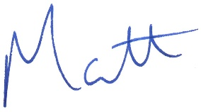

MATT HANCOCK

