11th February 2021

To all MPs and Peers  
  
Dear Colleague,

**THE DEPARTMENT OF HEALTH AND SOCIAL CARE’S LEGISLATIVE PROPOSALS FOR A HEALTH AND CARE BILL**

We are writing with regard to our recent publication of the White Paper ‘Integration and Innovation: working together to improve health and social care for all’, which sets out a series of legislative proposals that we plan to bring forward as part of a forthcoming Health & Care Bill.

In recent years, we have seen our health and care system evolving to meet the challenges of an ageing population, with a growing prevalence of long-term conditions and multiple comorbidities – challenges that are facing health systems around the world. Faced with this context the case for a continued focus on joining up care around people rather than around institutional silos was already well evidenced. This vision was central to the NHS’s Long Term Plan and remains vital for our health and care system. The measures outlined in this White Paper build on this work by the NHS across and will deliver the NHS’s ask for legislative reform set out in its Long Term Plan.

Furthermore, the experience of the Coronavirus Pandemic, the greatest challenge to the health and care system in living memory, has added to the imperative for change. We have seen incredible collaboration across health and care at a pace and scale unimaginable even a little over a year ago as all parts of the health and care system have worked to address the impacts of the pandemic. The NHS has consistently delivered outstanding care to those in need while at the same time radically changing ways of working, reducing bureaucracy and becoming ever more integrated.

As we now begin to look to the future it is vital that we capture this learning and make permanent those innovations that Covid has accelerated that have brought benefits for patient care, while in parallel continuing to address the longer term societal and structural drivers of health and social care provision for the future.

To do this the White Paper outlines proposals to remove the barriers that stop the system from joining up care for patients, and will drive the focus on population health and better health outcomes. We have worked closely with the NHS and local government to develop these reforms and as a result our Integrated Care Systems proposals closely align with NHSE’s policy recommendations set out in their document responding to their original consultation on Integrated Care Systems published today (‘Legislating for Integrated Care Systems: five recommendations to Government and Parliament’). We will remove unnecessary bureaucracy that has made sensible decision-making harder. Key to all of this will be enabling the use of technology in a modern way to better support staff and patient care. And finally, our proposals will make the system more accountable and responsive to the public and Parliament.

This legislative change is part of a broader reform. Legislation alone is not enough. It is, however, clear that some elements of the current legal framework need to be improved to make it easier for local leaders to innovate by removing barriers and providing greater flexibility. This legislation is intended to enable local Health and Care leaders to continue to deliver high-quality services and it will be supported by an implementation programme that recognises the importance of key non-legislative enablers in facilitating change. We will work closely with the health and care system to develop this programme.

**Wider Reform**

This legislation is not intended to address all the challenges faced by the health and social care system. Separately, this Government plans to undertake broader reforms to social care, public health and mental health. In January, this Government published Reforming the Mental Health Act, a White Paper which responds to the Independent Review of the Act in 2018. The White Paper sets out our proposals for a substantive programme of legislative reform, taking forward the Government’s commitment to legislate to give people greater control over their treatment, and ensure they are treated with the dignity and respect they deserve. Reforms to public health are underway, with the establishment of the National Institute for Health Protection (NIHP). And we recognise the pressures faced by social care and are committed to reform. A broad range of options are being explored for how best to accomplish these reform objectives, and we have committed to bringing forward proposals this year.

**Next Steps**

The response to Covid-19 is our current priority but we must also prepare for the recovery of our health and care system and learn lessons from this experience.

As such, we intend to bring forward legislation reflecting the proposals in this White Paper early in the next Parliamentary session.

We will ensure there are engagement opportunities over the coming weeks and months for colleagues in order to allow for discussion in greater detail of this legislative package and to hear colleagues’ views.

Yours ever,

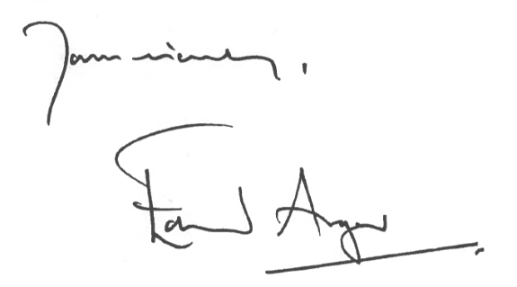



**Helen Whately**

Helen Whately

**Edward Argar (Bill Minister)**

Edward Argar

**Matt Hancock**

Matt Hancock

Matt Hancock



**Jo Churchill**

**Nadine Dorries**

**Lord Bethell**